**Planter for Tall Plants**

**Team 5**

**Grant Konyndyk, Jacob Brink, James Lee, and**

**Ella Bronkema**

**November 30, 2018**

**Engineering 101 C**

**Professor’s Wildschut**

**Abstract**

    Over the course of a few months, an engineering group at Calvin College was tasked with the redesign of planter pots for the Devries Hall Atrium. The team decided to design and create a wooden planter box, which would hopefully solve the two issues presented by the current planter boxes: a not so visually appealing look, and the need for a method by waterers to gauge overwatering. The team decided to build a hexagonal shaped pot, with both the drainage basin at the bottom and the potted soil at the top all concealed by the wood sides. A wood door was placed in one side which would allow waterers and not the average passerby to see whether they overwatered or not. When the prototype was finished, the client and all persons involved were asked to fill out a survey regarding the subjective quality of the pot’s looks. Although the pot was claimed to look ‘boxy,’ and the average response was that the look of the pot was not suitable for implementation, the pot did receive a high score for intuitive functionality. Even though the test results were not ideal, the engineering design process is iterative, meaning that the team refined the design as much as possible.

*****************page separator ************************************************

1. **Introduction (Grant)**

For our Service Design Project, the team was tasked with the challenge to design a planter that would effectively support tall and heavy plants in the DeVries Hall and Atrium. The team designed an effective, user friendly design that would be easy to build and aesthetically pleasing. Over the past month, the group has brainstormed, built and tested ideas in order to design the best product for our client.

1. **Problem Statement (James)**

Design a plant base to hold larger plants in both the DeVries Hall and the Atrium. The base should be visually appealing and should look professionally made. Try to make the base look simple, yet unique, and easily transportable.

One major problem with normal bases is that whoever waters the plant does not know when to stop watering. This causes the water to overfill inside of the base and escape through the outer side which then causes a build-up of Calcium on the outer edges of the base. A base should be made so the waterer will know when the plant has received enough water. This in turn will affect the amount of overfilling and over watering of the plant. These factors will decrease the chances of white Calcium build-up on the outside of the base.

* 1. ***Detailed Design Specifications (Jacob)***

When the team designed and constructed the planter’s pot, the team’s design was required to satisfy certain restrictions, objectives, and functions as described by the client.

Some restrictions placed on the design was that the design could only contain materials available in the Calvin woodshop and those purchasable for less than twenty dollars. As a result, this meant that the team could only use wood as the primary building block for the structure, and the limit on spending for outside resources also limited options for design. Another constraint on the project was the minimum size requirement. According to the client, the planter pot was supposed to be just as big or even bigger than a prototype done by a previous design group.

Although the design had limitations, the design was expected to function as a universal planter pot for all the plants in the Devries Hall. The primary function of the pot was to hold the weight of the soil, the water, and the plant. The pot was also expected to combat over watering and root rot by allowing water to drain out from the soil and into a collecting area, instead of letting the water sit in the soil until evaporated. However, one of the key functions of the pot was to provide a method of concealing the water drainage from the pot for the average passerby, but allow easy access of the drained water for the waterers.

In addition to the restrictions and the functions, the design needed to have a pleasing aesthetic look and be applicable to all different kinds of plants. Without this objective met, the underlying goal of the client to make the Devries Hall’s plants look more organized and uniform could not be met.

* 1. ***Project Plan (Ella)***

The timetable for our project was sloppy and we took way longer than we should have to complete it, for three reasons:

1. We didn’t pick a team leader, so our group wasn’t very organized and we couldn’t communicate well who was supposed to do what.
2. We all had conflicting schedules, which wouldn’t have been *that* much of a problem since we all had some time off after 3 pretty much every day. But the wood shop closes at 4, so we barely had any time to work there, and could never work there as a full team.
3. I misunderstood the steps necessary to completing the project when creating the Gantt chart. This part is entirely my fault. I had not been paying attention when the instructions were being given, so I missed some steps that were needed (for example, Create computerized model) and added some steps that were not (like re-pot all the plants). I also didn’t add in the dates at the beginning, and now I can’t figure out on which days we did all the steps.

|  |  |  |  |  |  |  |  |  |  |  |  |  |  |  |
| --- | --- | --- | --- | --- | --- | --- | --- | --- | --- | --- | --- | --- | --- | --- |
|  | Assignment of project | beginning |  |  |  |  | Approximate middle |  | 11/2/2018 |  |  | 11/30/18  Rough Draft Due | weekend | Final project due |
| Research Materials | JL and JB |  |  |  |  |  |  |  |  |  |  |  |  |  |
| Research Style | GK and EB |  |  |  |  |  |  |  |  |  |  |  |  |  |
| Interview Client | JL, JB, GK, EB |  |  |  |  |  |  |  |  |  |  |  |  |  |
| Note Planters |  | JL, JB, GK, EB | JL, JB, GK, EB | JL, JB, GK, EB |  |  |  |  |  |  |  |  |  |  |
| Brainstorm |  | JL, JB, GK, EB | JL, JB, GK, EB | JL, JB, GK, EB |  |  |  |  |  |  |  |  |  |  |
| Create computerized  model |  |  |  |  | JL, JB, GK, EB | JL, JB, GK, EB | JL, JB, GK, EB | JL, JB, GK, EB |  |  |  |  |  |  |
| buy materials |  |  |  |  |  |  |  |  | Prof. Wildschut | Prof. Wildschut |  |  |  |  |
| Make prototype |  |  |  |  |  |  |  |  | JL, JB, GK, EB | JL, JB, GK, EB | JL, JB, GK, EB |  |  |  |
| Write report/ refine report |  |  |  |  |  |  |  |  |  |  | JL, JB, GK, EB | JL, JB, GK, EB | JL, JB, GK, EB(refining) |  |
| Present |  |  |  |  |  |  |  |  |  |  |  |  |  | JL, JB, GK, EB |

1. **Project Design (Grant)**

Our first task of the engineering design process was defining the problem. We met with

Professor Warners and he explained to us that problem the current pots lacked that support to hold up larger plants.  So we set off to work brainstorming the best ideas and what does and doesn't work. We did some research and we narrowed it down to 3 simple designs: circle, square and hexagonal. We determined that the circle would be too complicated to make and the square did not look appealing enough. So we decided on the hexagonal shape which was both appealing and fairly easy to construct. We then had to figure out the height if it was too tall it would be top heavy and have the possibility of tipping over but too short would look strange. So we settled on 16in this way the planter was both appealing and supportive. Next was the prototype first we designed it on inventor to figure out the prototype design. Then it was off to the races creation our prototype. Once our prototype was created we tested it. One key flaw we found was the the dirt was falling in between the walls and the dirt floor. So we decided to fill the cracks with shims and hot glue to fix it. We tested it again and sure enough it did the trick. Overall we used the design process to design an effective design for our client.

**Design Alternatives (possible solutions) (James)**

After the team decided to go with the hexagonal base, they were faced with yet another challenge: how to make sure the waterer does not overwater the plant. There are few different solutions the team came up with to solve this problem. For example, one possible solution was to use a Moisture Meter so the waterer will know when to stop watering. The moisture meter would determine how moist the dirt is and then know when to stop watering. There would have been a small indicator towards the bottom of the plant base to indicate at what number the waterer could stop watering. The team was set on using this idea for a long time until the client, Professor Warners, said “I honestly don't know if a moisture meter would be ok. It might be, but there might also be something to having the water flow through the root zone and not having long residence time there. At least for some plants it may be detrimental to even have their roots in saturated conditions for a day or two. For other plants more adapted to wet conditions, it probably wouldn't matter”. With this in mind, the idea of using a Moisture Meter went down the drain.

Another possible solution the team came up with was to somehow connect a glass tube from the bottom of the plant base to the top. In all of the designs, there was a little bit of empty space between the dirt and bottom of the planter base so the excess water could be collected and then evaporated. The glass tube would have somehow been connected to the pool of excess water and then shown at the top of the base. When brainstorming this idea, the team ran into more obstacles. For example, it takes a long time for the water to seep through all of the dirt into the bottom so the waterer would have to stand there and wait to see the water level. Also, because the water takes a long time to reach the bottom, the waterer could already be over watering the plant before knowing. There were too many problems with this solution so the team moved onto their third and last one.

The last possible solution was to cut out a door on one of the six sides and fill the cut with plexiglass. This would help the waterer know how much water to pour into the plant because they would be able to physically see the water going down the dirt. The team decided to use this solution even though water takes a long time to reach the bottom, because the door would be be made towards the middle of the entire plant base. Even though dirt is dark and it would be hard to see when the water has reached the middle, the difference between dry dirt and wet dirt is easily distinguishable. This design would still be simple, but it would be very unique in a way that people can actually see the dirt through glass and determine when to stop watering.

**Final Design (Jacob)**

    The final design of the planter pot utilized a door mechanism instead of the moistrometer solution, because of the unreliability of a moistrometer and the client’s doubt the meter would work as a solution.

    According to qualitative testing, where the client and all those involved were asked how they would rate the physical appearance and the functionality of the prototype, the prototype design did not seem to meet expectations. The average score of the testing of the functionality was a 3 out of a 5, where five was considered highly functional and intuitive design. When asked to rate the look of the design with the same scale of 1 to 5, the average score was only 1. With such poor testing results, the team was forced to redesign the prototype.

   Since not enough time was given for change complete redesign, only a few possible ideas for a redesign were considered. One of the problems the client had with the prototype was that it looked like a box more than a pot. As a result, one idea was to increase the number of sides to the polygonal shape, so that the pot would have a more circular shape. Some thought making a circular pot would be best for the client's preferences, but the manufacturing capability and the restrictions of materials prevented the team from pursuing the ideal shape.

Present your final design.  This is the design that you are recommending to your client that incorporates all of your testing and redesigning.  Be sure to include explanations of both what you chose and why you chose it.  Describe the size, shape, and material, and explain how the user would use it.  Remember, your client should be convinced that this design will work and have enough information to create the design.  Discuss why this was the best approach (unless fully discussed in the previous section).

* + 1. **Bill of Materials and Budget (Ella)**

Materials used for prototype:

1. Three Mending braces 4x5/8, for holding the sides of the pot together, for a total of $7.44
   1. These ended up being replaced with wood glue, but will still likely be used in the final product
2. One Flat Philips Sheet metal screws 10x2, to attach the bottom to the sides, $4.98
3. One Hinge 1/12x1/14, to attach the door to the pot, $2.48

For a total of $14.90.

What will be added to the final product:

1. Paint. At Lowe’s, a can of porch paint, which would be the best choice of paint for this project, typically costs just under $30. Paint would be used on the exterior of the final product to make it look good. Cost: Probably $29, but it depends on the color.

Time budget: We were not able to budget our time very well. This was partly because we didn’t pick a team leader, and were therefore less organized, and partly because our schedules often conflicted. However, once we got the steps on the Gantt Chart in order, we were able to get everything done on time. It took the entire time that was available to us, but with better organization should not have taken that long.

* + 1. **CAD Design (Jacob)**

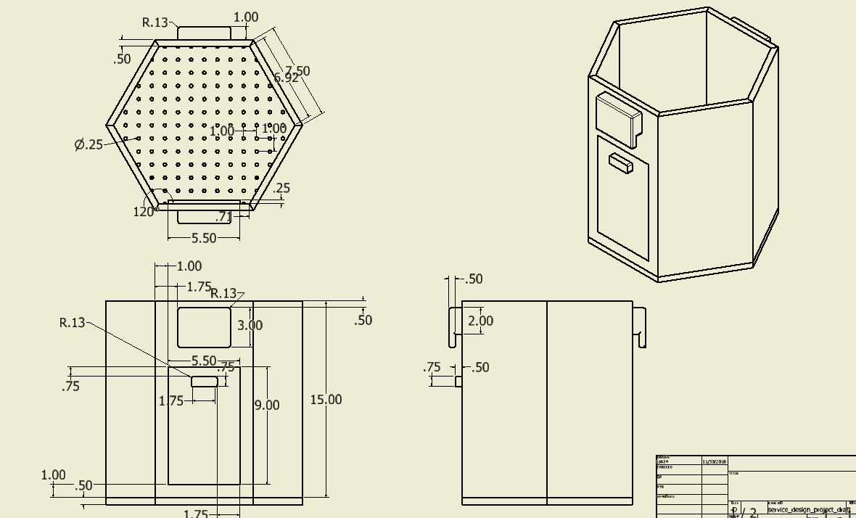

Figure 3.1.2  CAD drawings showing the pot design.

* + 1. **Prototype Construction (Grant)**

        After determining the best design for our project we dove into the prototype phase. Our prototype consists of a hexagonal shape with a base. We designed the planter to have a hexagon hexagon to hold the dirt above the bottom of the planter to let the water seep through allowing for not too much water build up.  In order to create the walls for the hexagonal planter they needed to be at an angle of 60 degrees. Since no of us we super great wood workers it took trial and error to get the right angle on the table saw. Once we got the base and walls completed we started on the dirt platform. To do so we had to copy the hexagonal base and drill holes for the water to pass through to the bottom.  Also, we added a door for easy access to the bottom of the planter. We also added a clear plexiglass window which allows for the waterer to easily figure out how much water is in the planter since a moisture reader would not be suitable. Another thing we added to our prototype was wooden handles. These handles allowed for easy transportation between places. Below is our picture of our prototype.  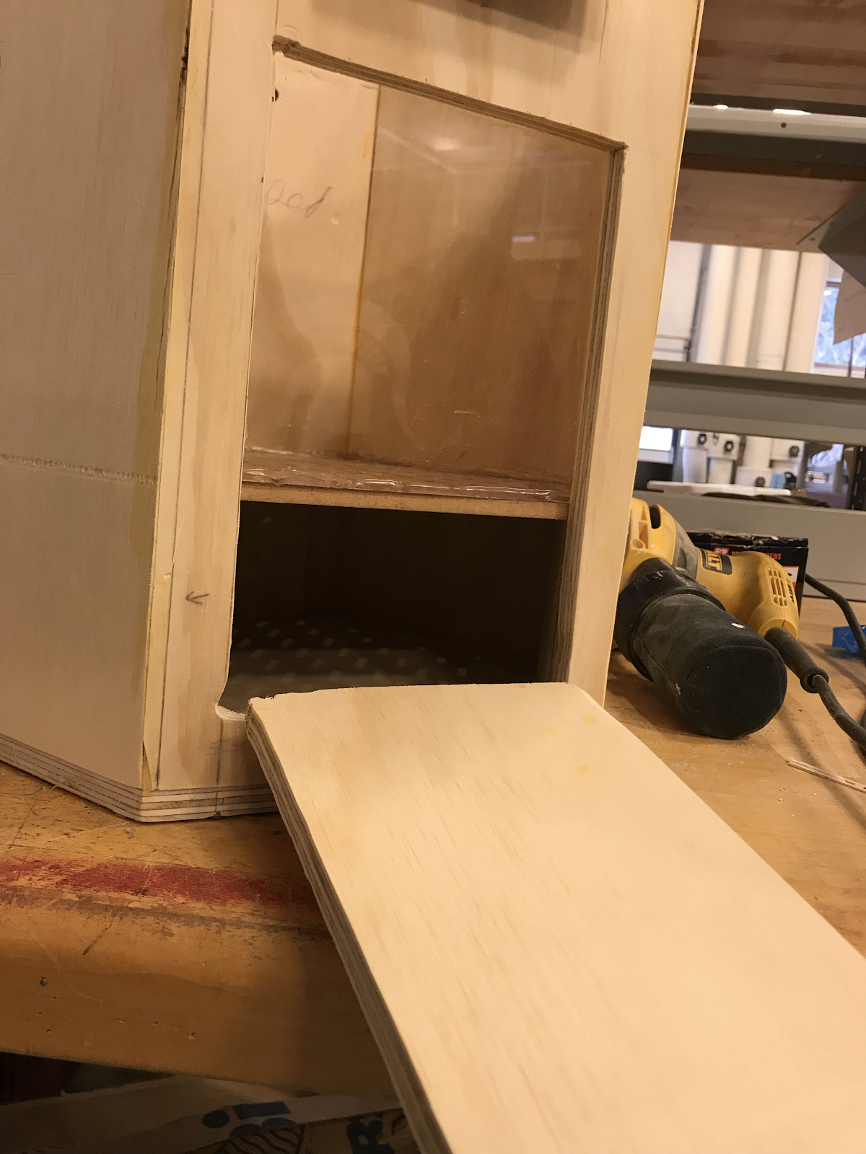

* + 1. **Testing Summary:**

    With such qualitative requirements for the design by the client, the team designed an online form asking the client and those involved to rate from 1 to 5 how much the design looked visually appealing and how intuitive it would be for waterers to use.

    Concerning the qualitative test results, the design did not seem to meet the expectations for a good looking pot. Even though the design shared its shape with a previous design that the client approved of, the design received a very low score of 1 out of 5 for implementation. The score one was assigned the value of ‘would not implement because of the look.’ However, when asked about the intuitive design, the pot was rated moderately, with an average of 3.5 out of 5. One of the reasons the results may be lower than actual was the angle of the pictures given in the online form. Most photos did not highlight the relatively good looking, ‘non boxy’ shape.

1. **Conclusion**

In conclusion, the team may have not developed the ideal solution to the planter’s problems. However, the team did what was meant for the project: they learned about the design process, how important organization is, and how communication with the client and team members is crucial to success.

**References**

Include a list of references used in this project.  This should include any text-based or electronic information along with any interview with persons who provided assistance.

Interview:

Dave Warners (Client)

Email:        [dwarners@calvin.edu](mailto:dwarners@calvin.edu)

Phone:     (616) 526-6820

**Appendices**

Use an appendix title page (with an optional appendix table of contents) to separate the report body from any large tables of data or sets of drawings which are included in the appendix.  The pages in the appendix should all be numbered and Appendix A should be clearly distinguished from Appendix B, etc. All tables and figures should have titles and numbers like those used in figures and tables in the body of the paper, but would probably be prefixed with the appendix number (e.g. Figure A1….).   An appendix is not a dumping ground for miscellaneous sketches or rough computations. For this project, you may not need to include any appendices.

*******************page separator – done to save paper for this printout****************

Appendices begin here.